Introduction
The purpose of this project is to develop a QR Code Generator application using Python programming language. The application allows users to enter a URL and automatically generate a QR code image. QR codes are commonly used for storing website links, contact details, payment information, and other digital data in a machine-readable format. This project helps in understanding the practical implementation of Python programming for real-world applications.
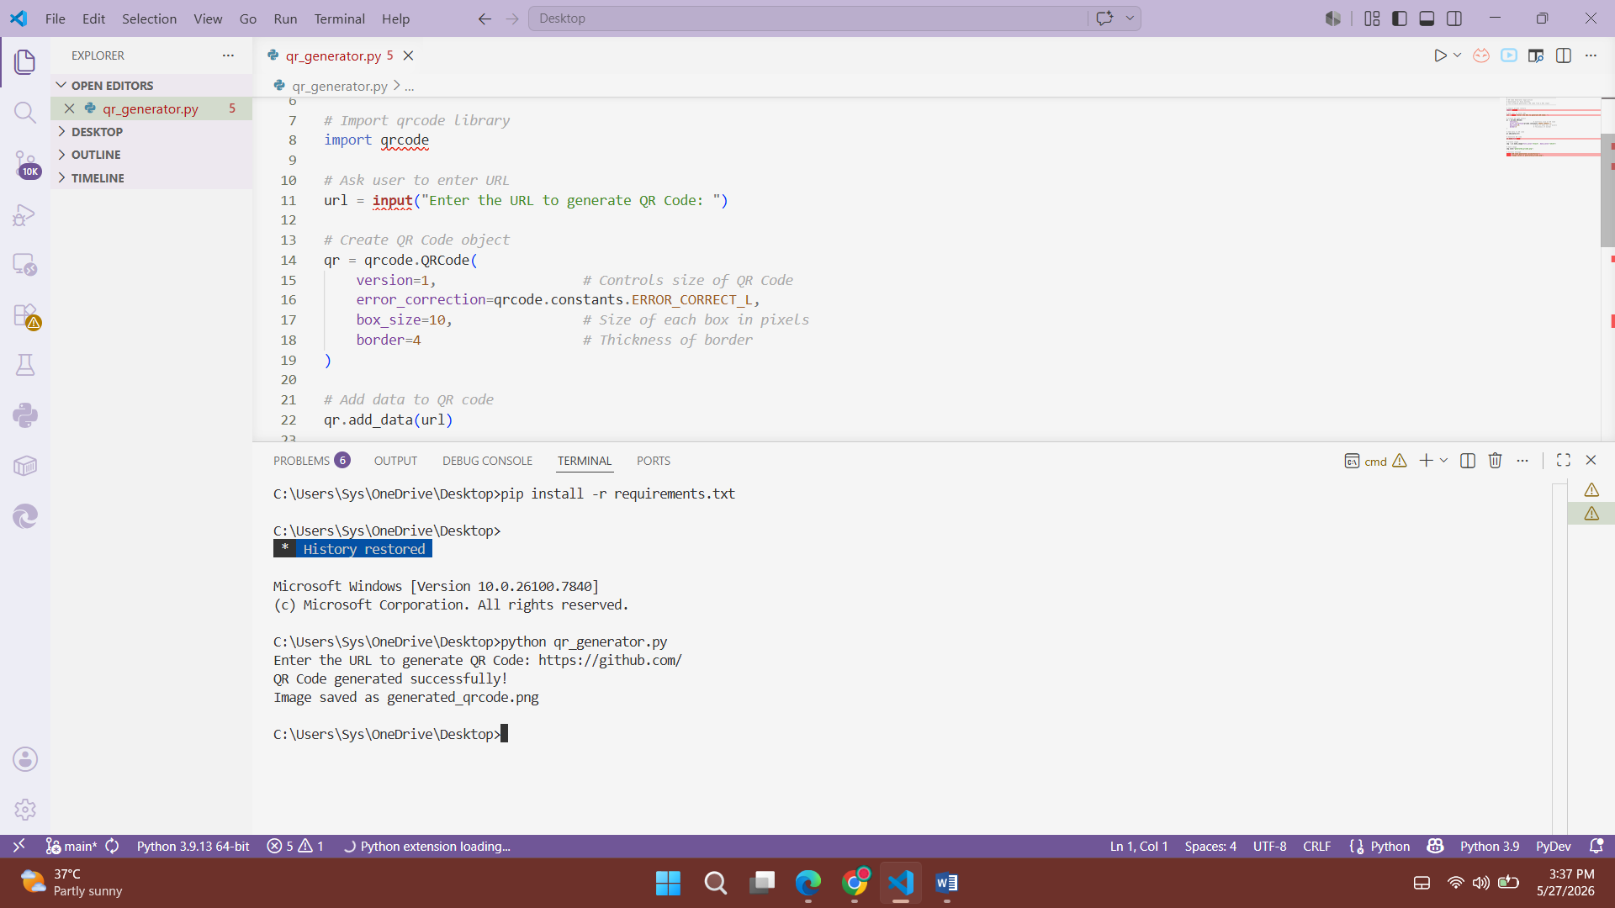
Tools and Technologies Used
The project was developed using Python programming language along with the qrcode library for generating QR codes. The Pillow library was used for image processing support. Visual Studio Code was used as the Integrated Development Environment (IDE) for writing and executing the code. GitHub was used for version control and sharing the project files online.
Working Process
The application first asks the user to enter a website URL. After receiving the input, the qrcode library processes the data and creates a QR code object. The program then generates a QR code image based on the entered URL and saves the image as a PNG file in the project folder. Finally, a success message is displayed to the user confirming that the QR code has been generated successfully.
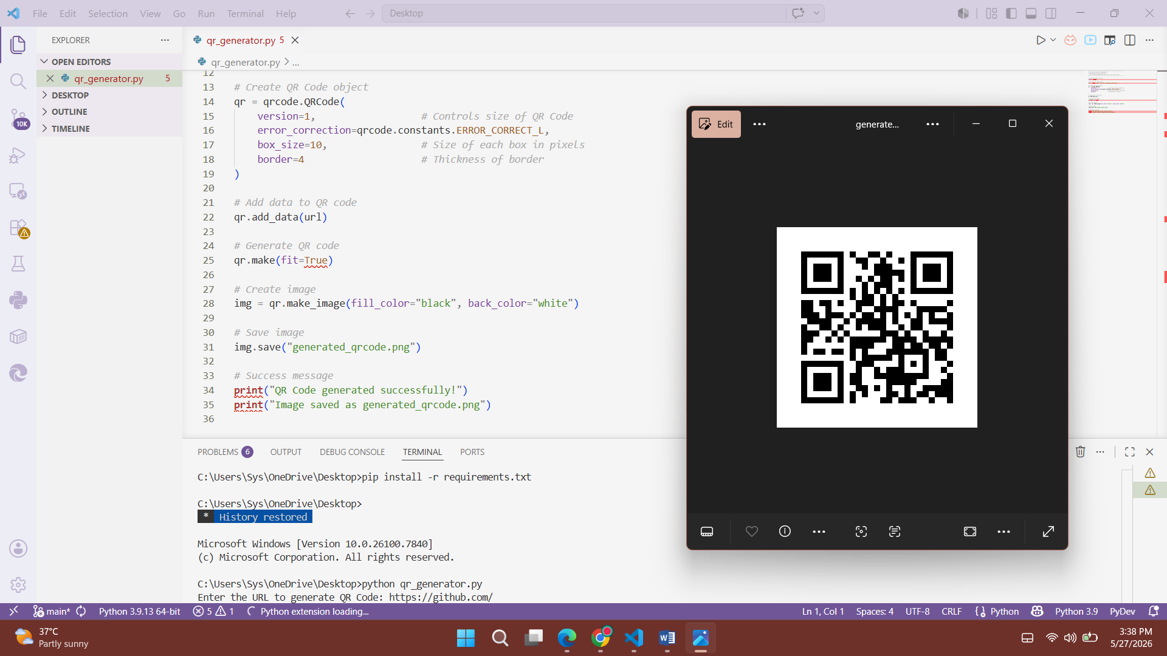
Output
The application successfully generates a QR code image from the user-provided URL. The generated QR code can be scanned using a smartphone camera or QR scanner application to directly open the corresponding website link. The output image is stored in the project directory for future use.
Conclusion
This project demonstrates the practical implementation of Python libraries for generating QR codes efficiently. It also provides knowledge about user input handling, image generation, and file management in Python programming. Overall, the project successfully achieved its objective of creating a functional QR Code Generator application.
GitHub Repository Link:

